**NATIONAL INSTITUTE OF TECHNOLOGY KARNATAKA SURATHKAL**

**DEPARTMENT OF INFORMATION TECHNOLOGY**

**IT 301 Parallel Computing LAB 5**

**9th September 2020**

**Faculty: Dr. Geetha V and Mrs. Thanmayee**

--------------------------------------------------------------------------------------------------------------------------

**Name**: Chinmayi C. Ramakrishna

**Roll No**.: 181IT113

Develop a parallel program to find a given element in an unsorted array (a large number of elements starting from 10K can range to 1 lakh and above, based on the memory) using Linear Search. Compare the execution time with the Sequential Linear Search program. Also compare it with the sequential Binary Search program.

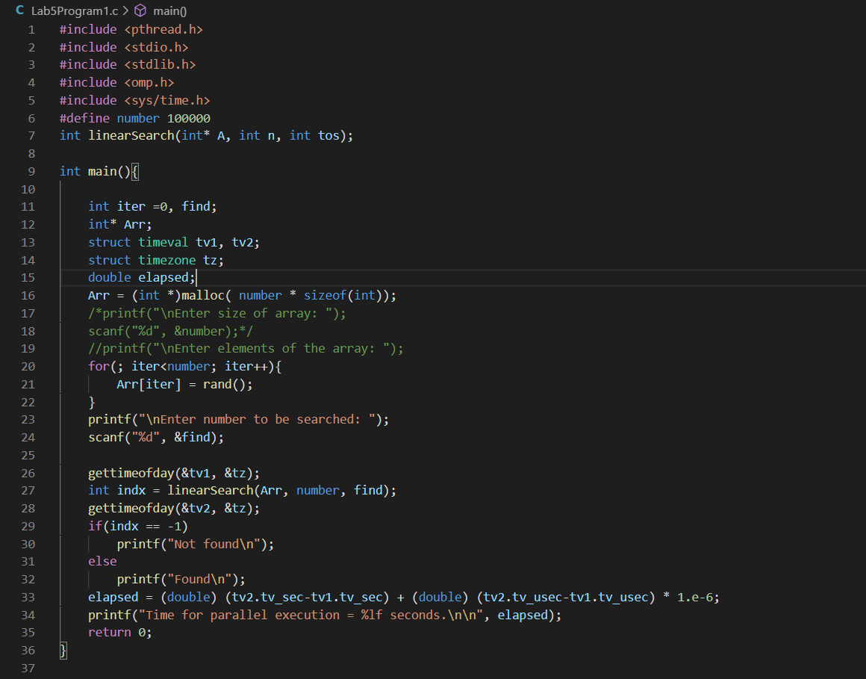

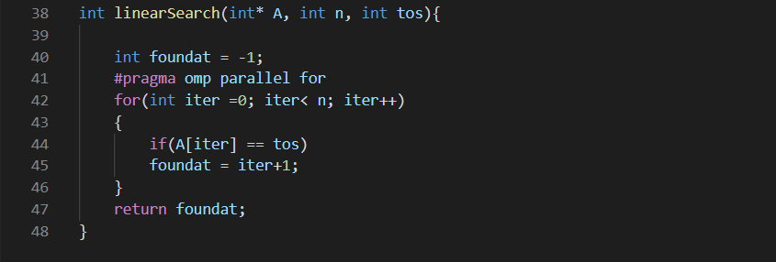

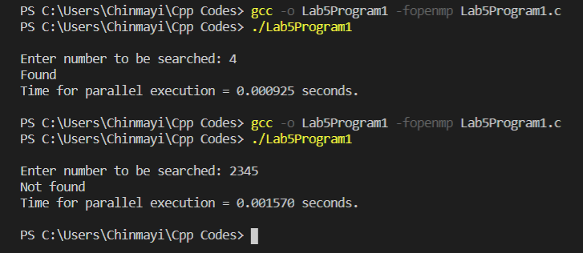

Array size = 10K.

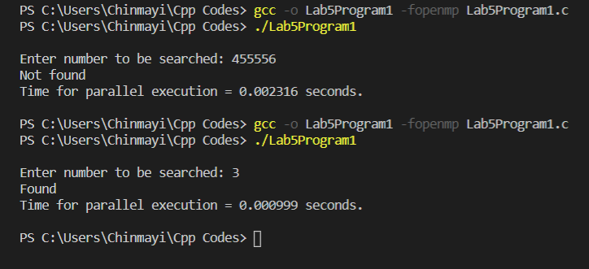

Array size = 1 Lakh.

Comparing Parallel Linear Search with sequential Linear Search.

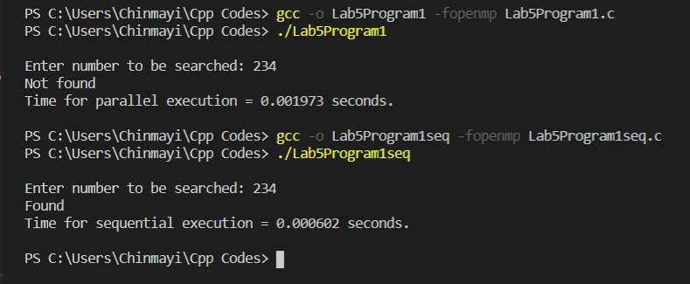

Array size = 10K.

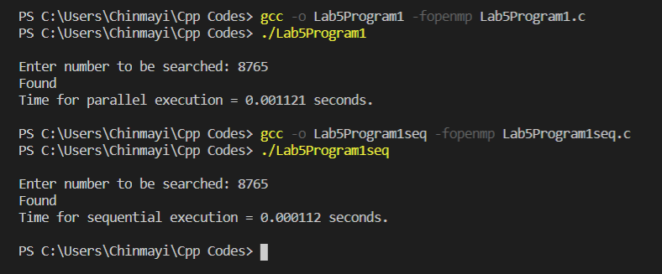

Array size = 1Lakh.

Comparing Parallel Linear Search with Sequential Binary Search.

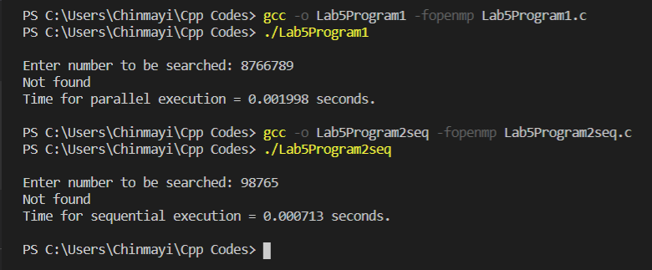

Array size = 10K.

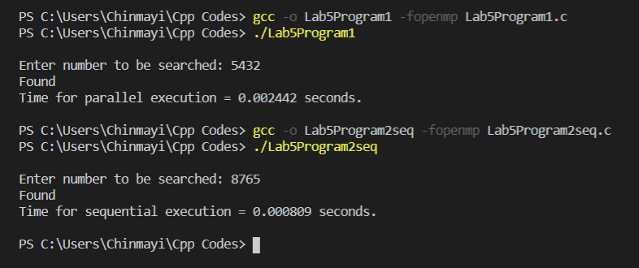

Array size = 1Lakh.

Develop a parallel program to find a given element in an unsorted array using Binary Search. Take a large number of elements up to the maximum possible size. Note: Make use of openmp task directive. Also compare the execution time with the sequential version of Binary Search.

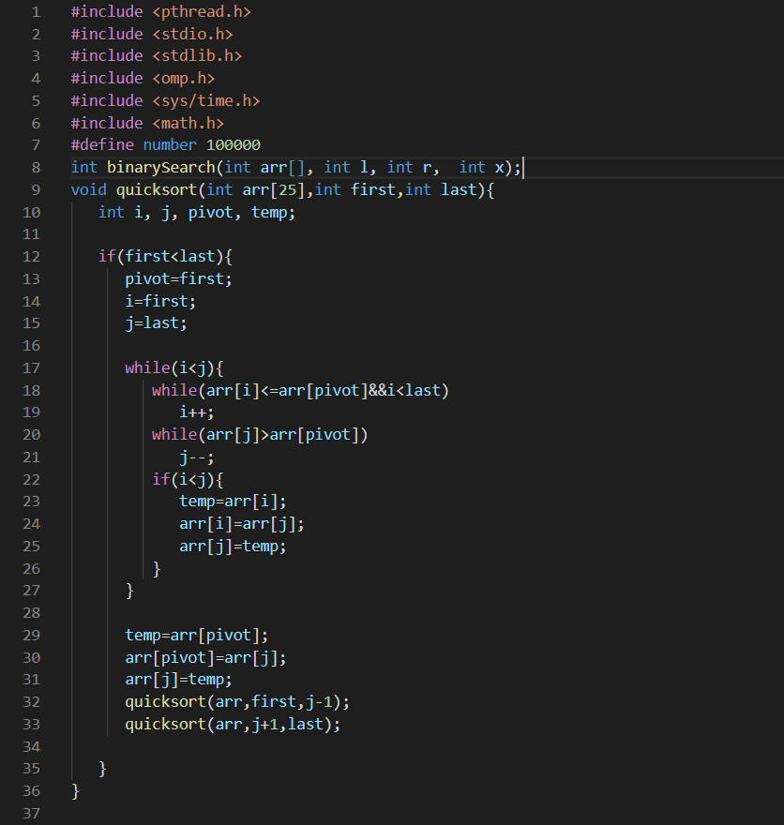

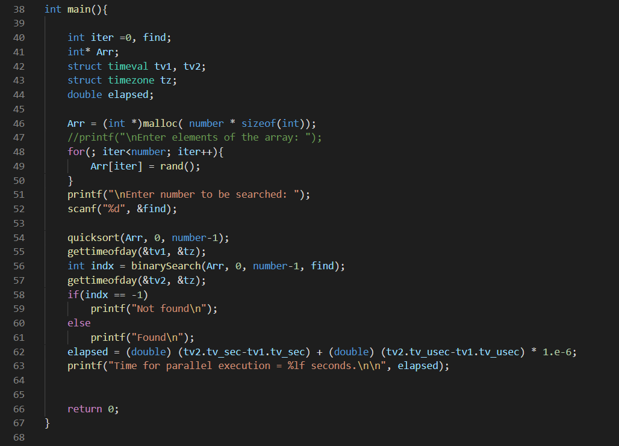

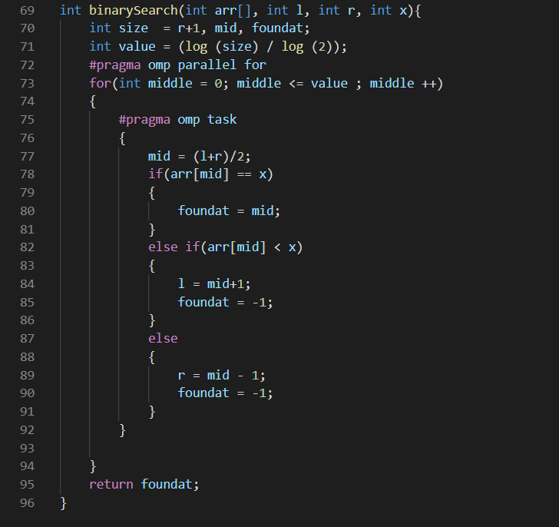

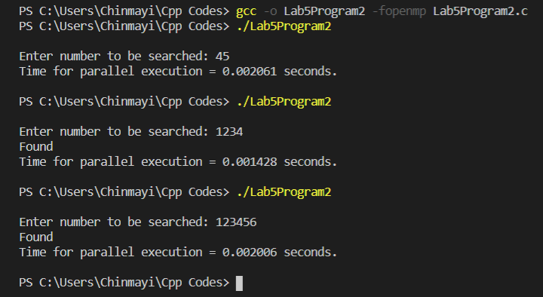

Array size = 10K.

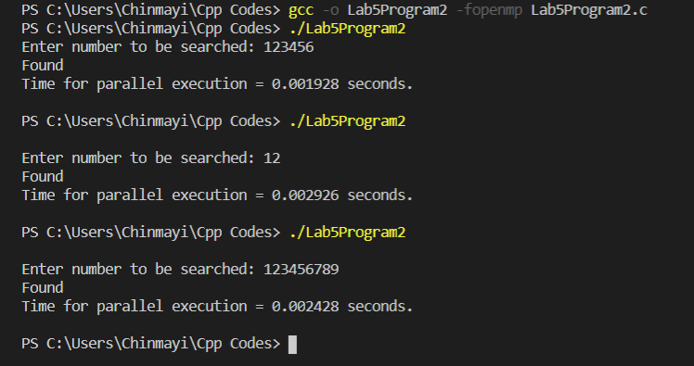

Array size = 1 Lakh.

Comparing Parallel Binary Search with Sequential Binary Search.

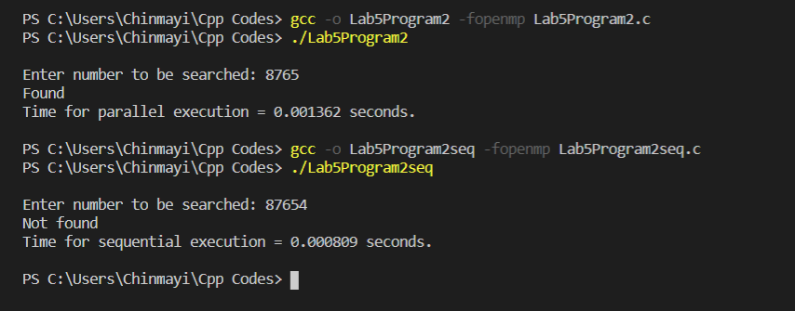

Array size = 10K.

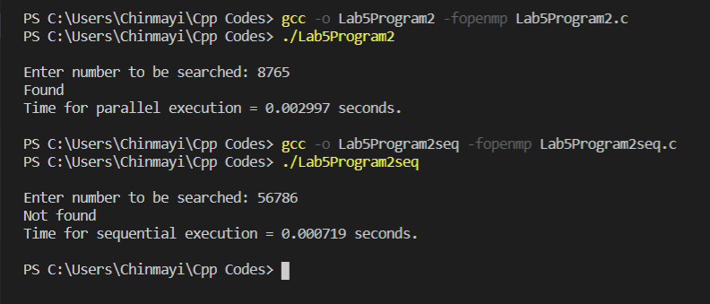

Array size = 1Lakh.

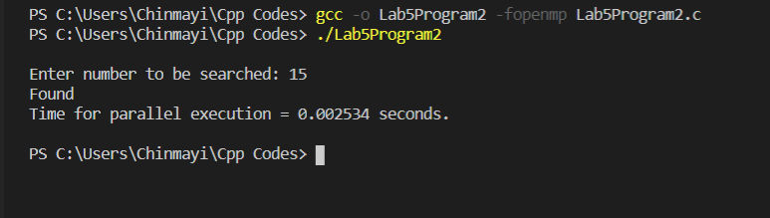

Array size = 10000000.